SPRING SECURITY NOTES:

* Configure user directly using application.properties

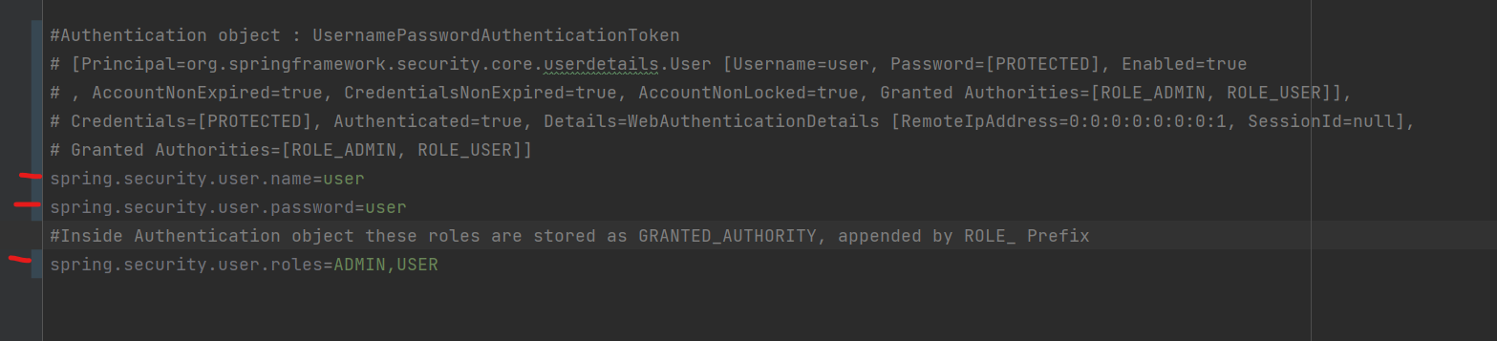

* How to configure multiple users using InMemoryUserDetailsManager.java?

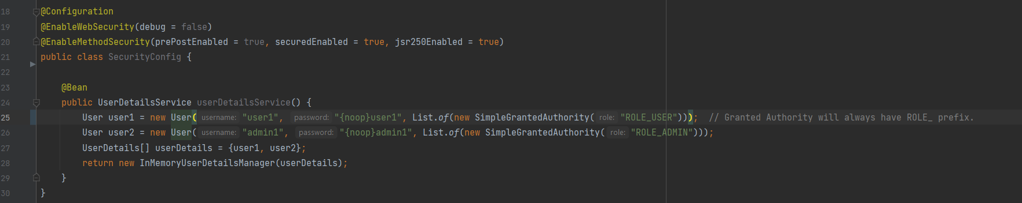

* What is the use of UserDetails in spring security?

It’s an interface used to store user details (name is self-explanatory) we can implement according to our need.

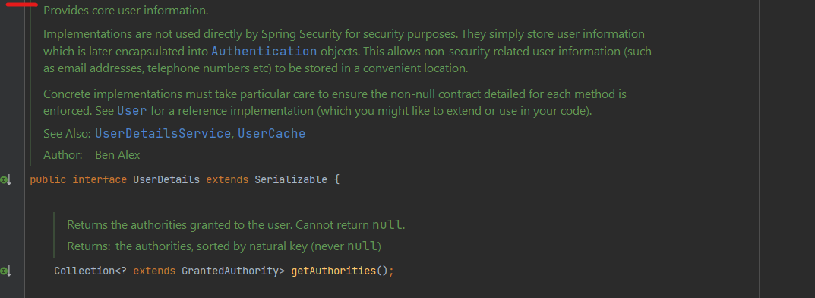

* What is **UserDetailService** and its spring provided implementation?

It’s a Service layer interface which can be extended and is used to fetch UserDetails with contains Username, pwd and authorities.

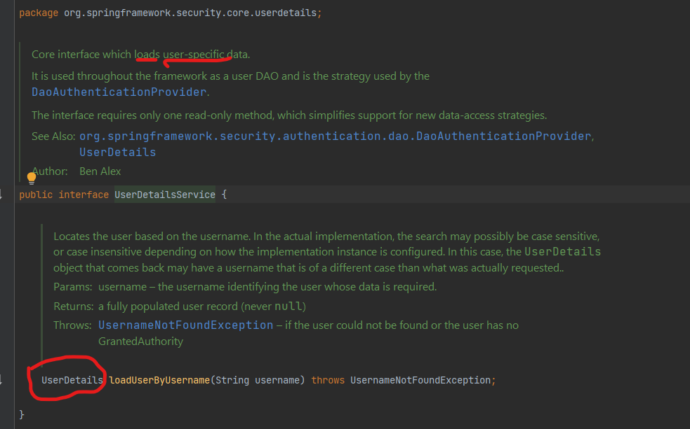

* What is UserDetailsManager in spring security, And its implementation?

It’s an Extension of UserDetailService.java interface,

* Its implementation are 🡪 **InMemoryUserDetailsManager.java** **& JdbcUserDetailsManager.java**

